Create a freestyle project with the name QA_UNIT_TEST in Jenkins that is driven from job DEVELOPER_CODE_REVIEW and performs unit testing

Take a screenshot of the console output showing a successful build of unit testing

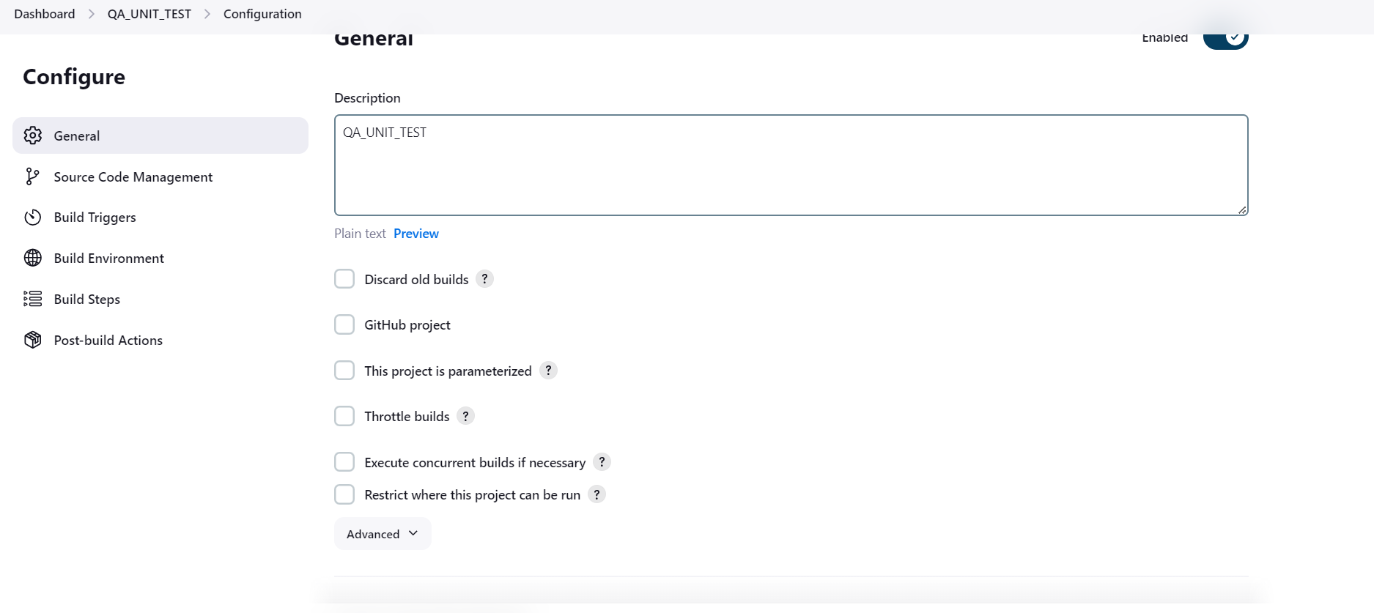

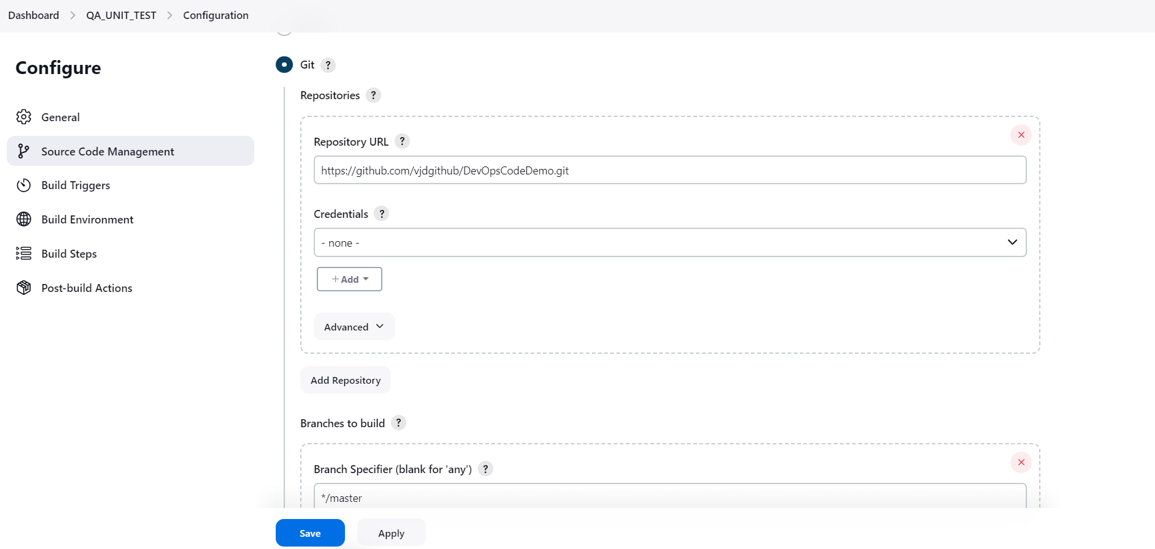

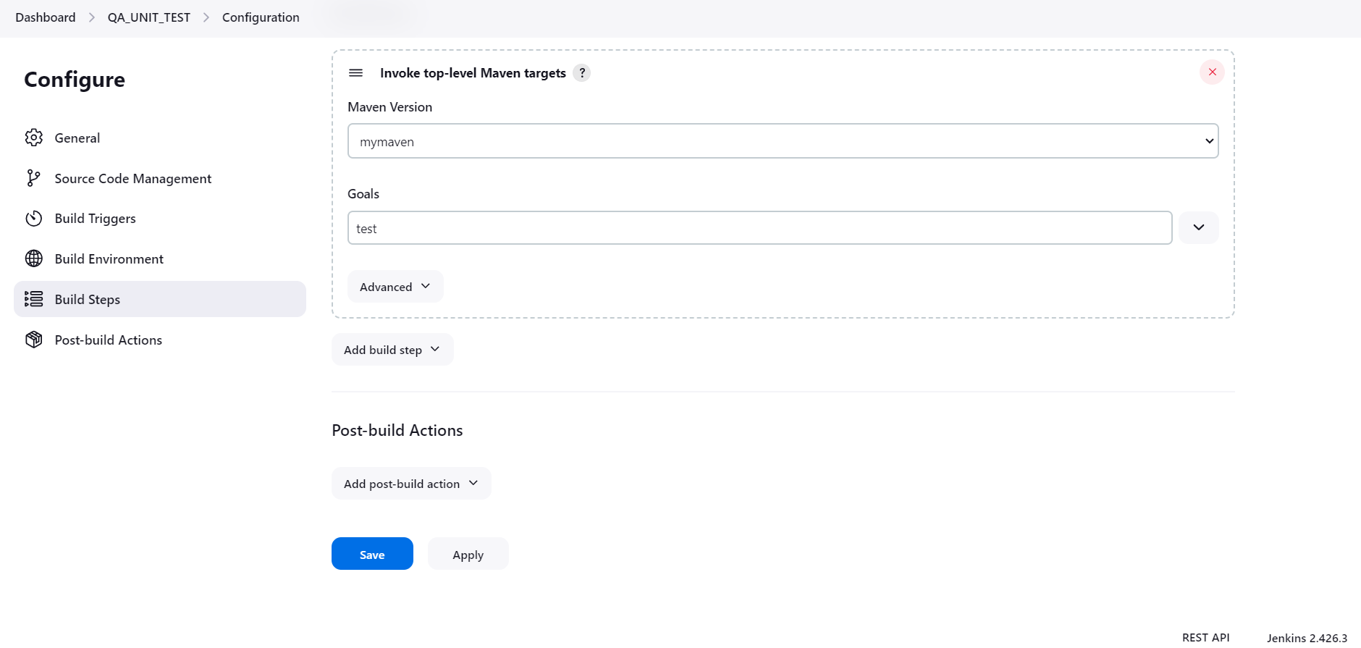

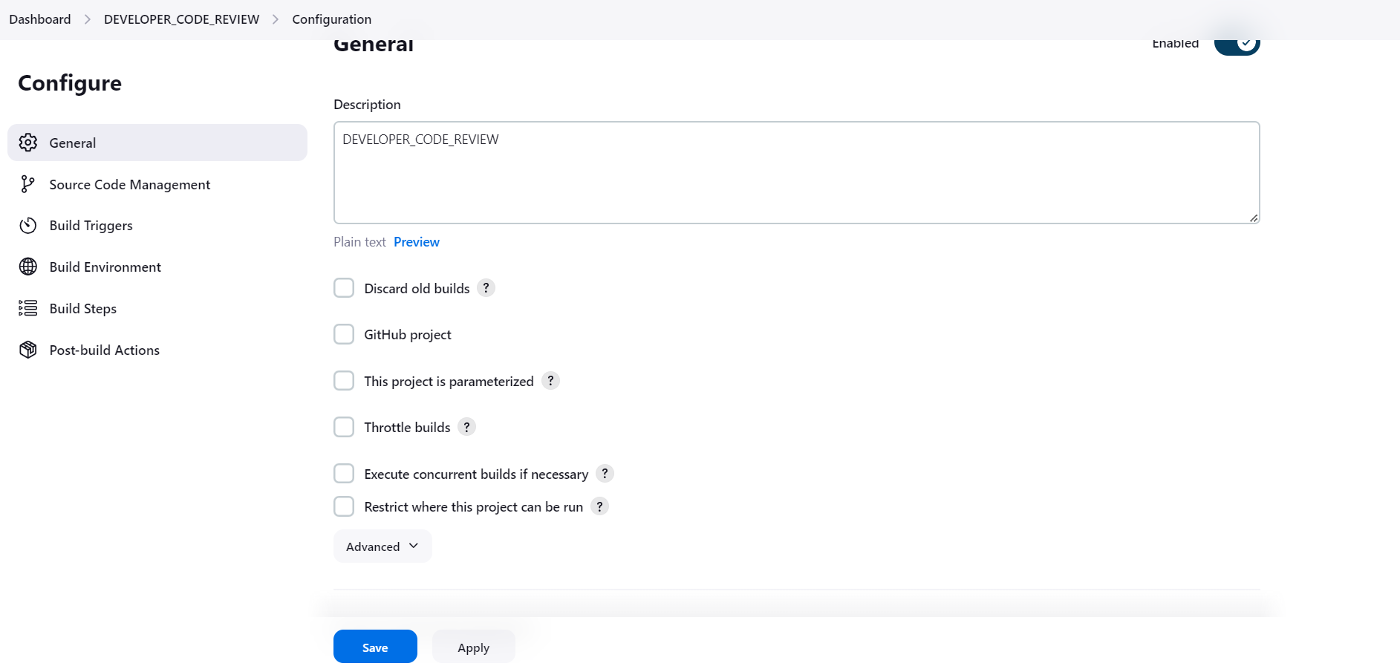

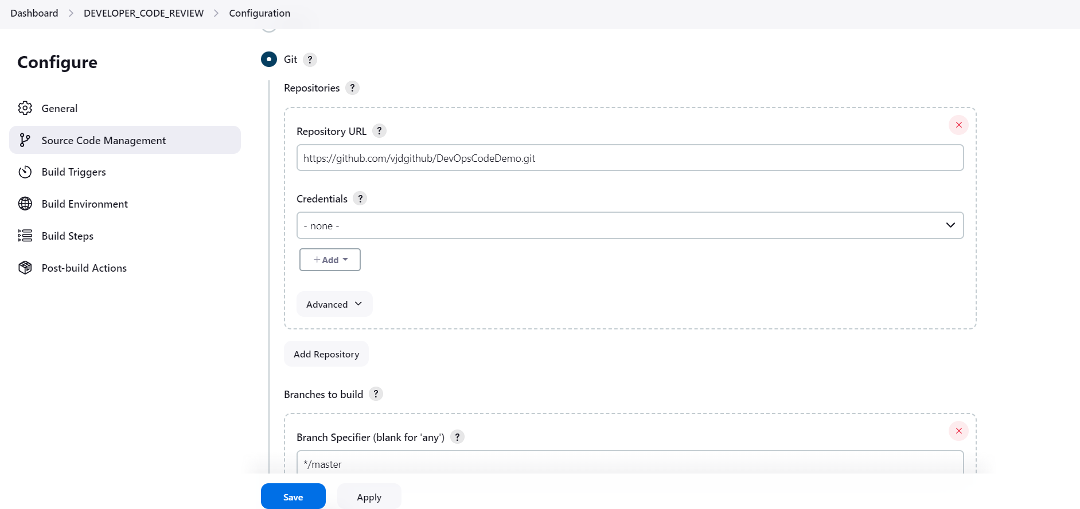

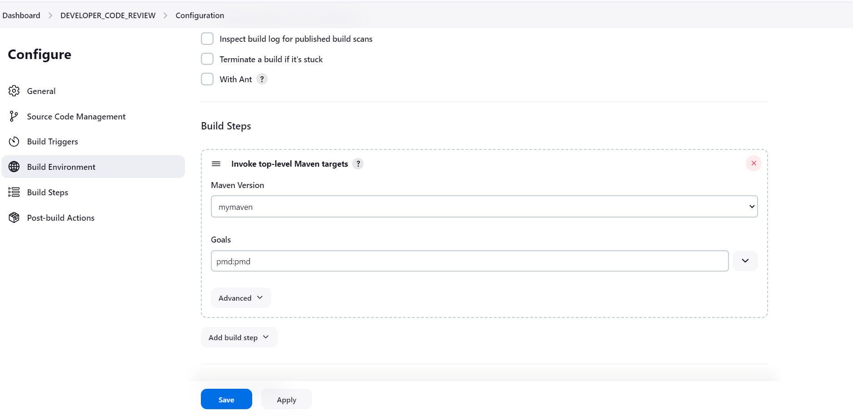

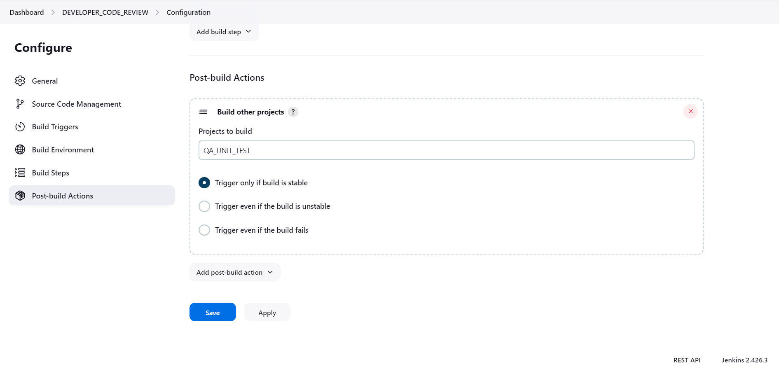

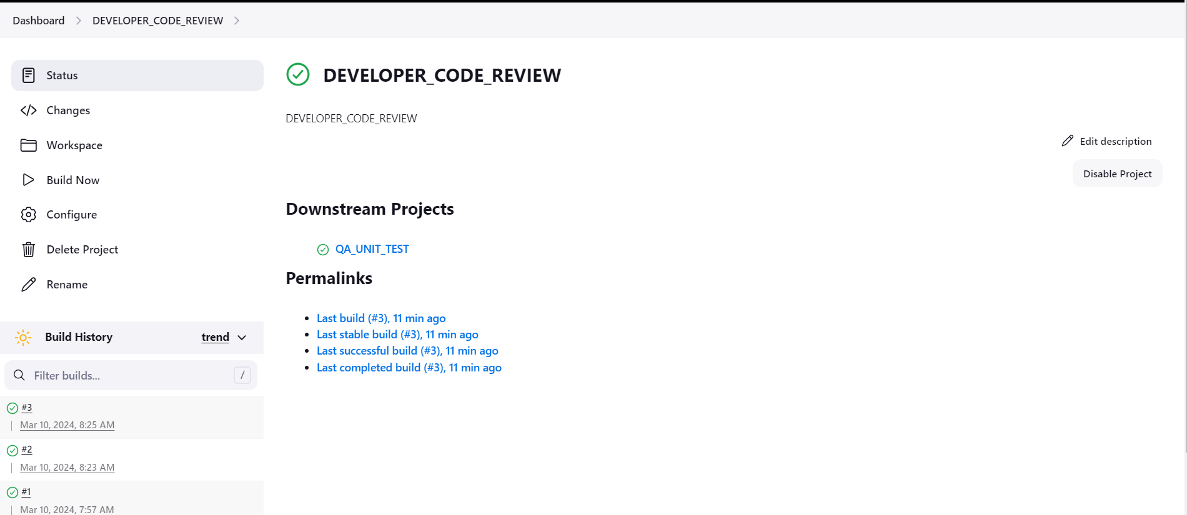

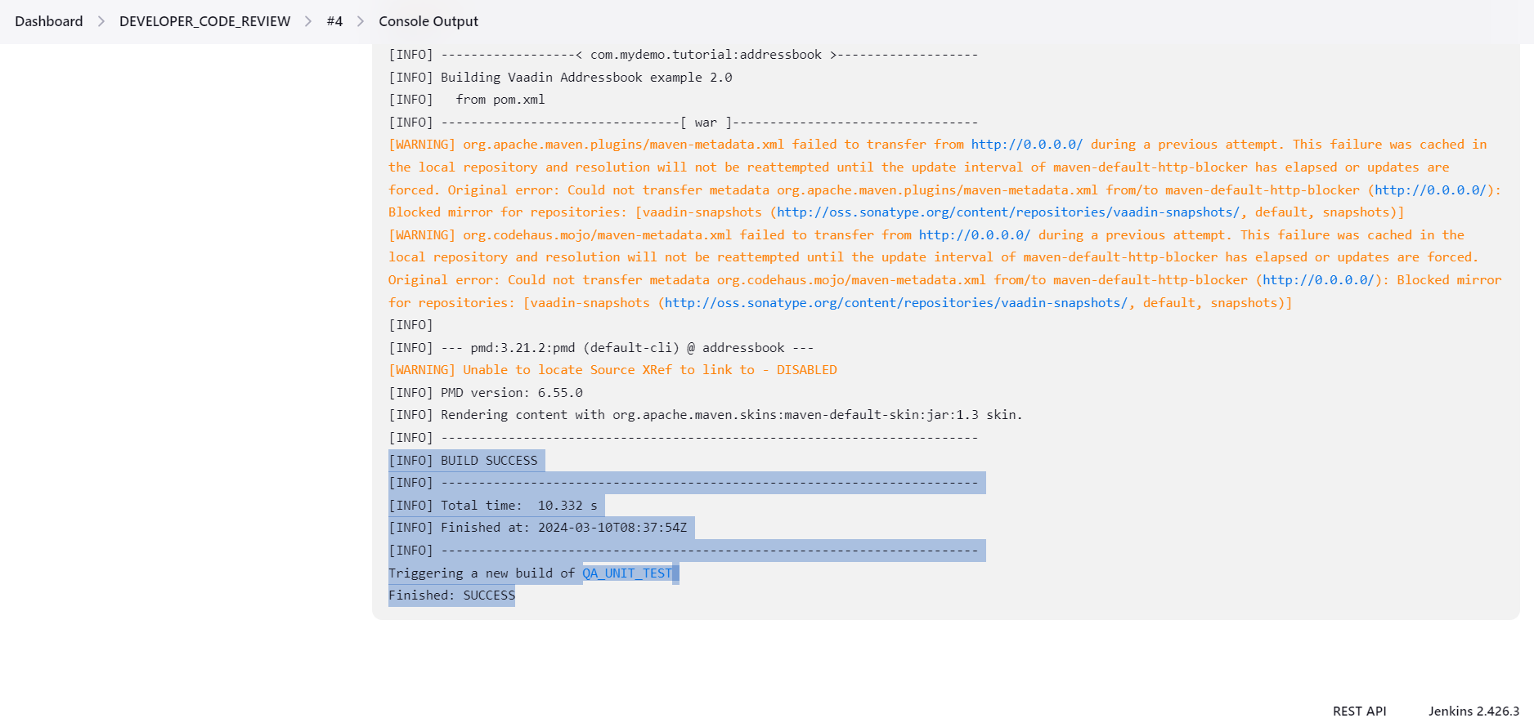

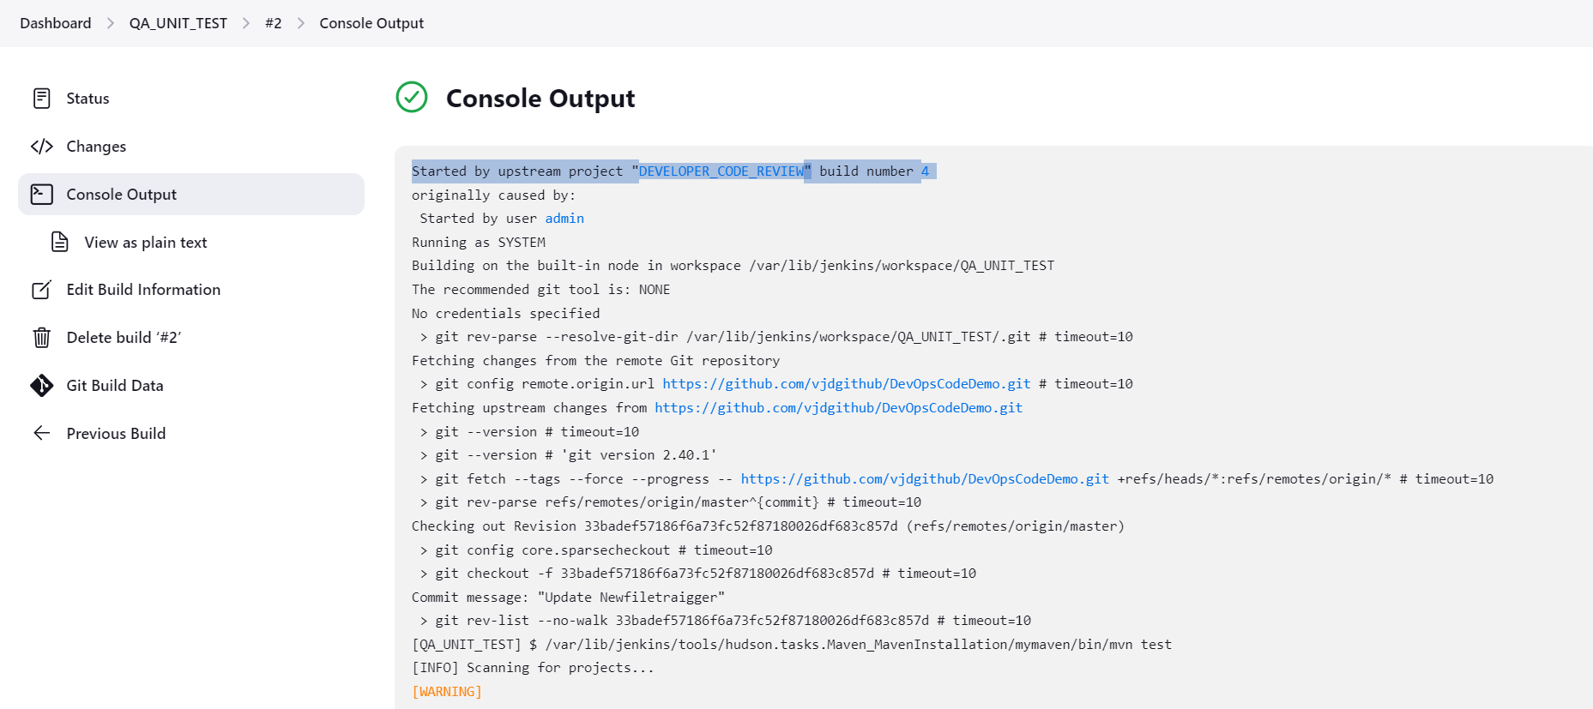

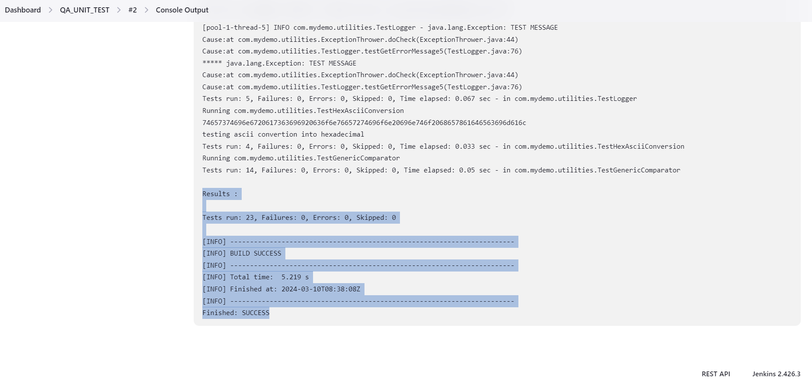

• Create a freestyle project with the name QA_ METRICS _CHECK in Jenkins to check the test cases.

Make sure the Cobertura plugin is installed in Jenkins

Take a screenshot of the metrics from the dashboard of the project.

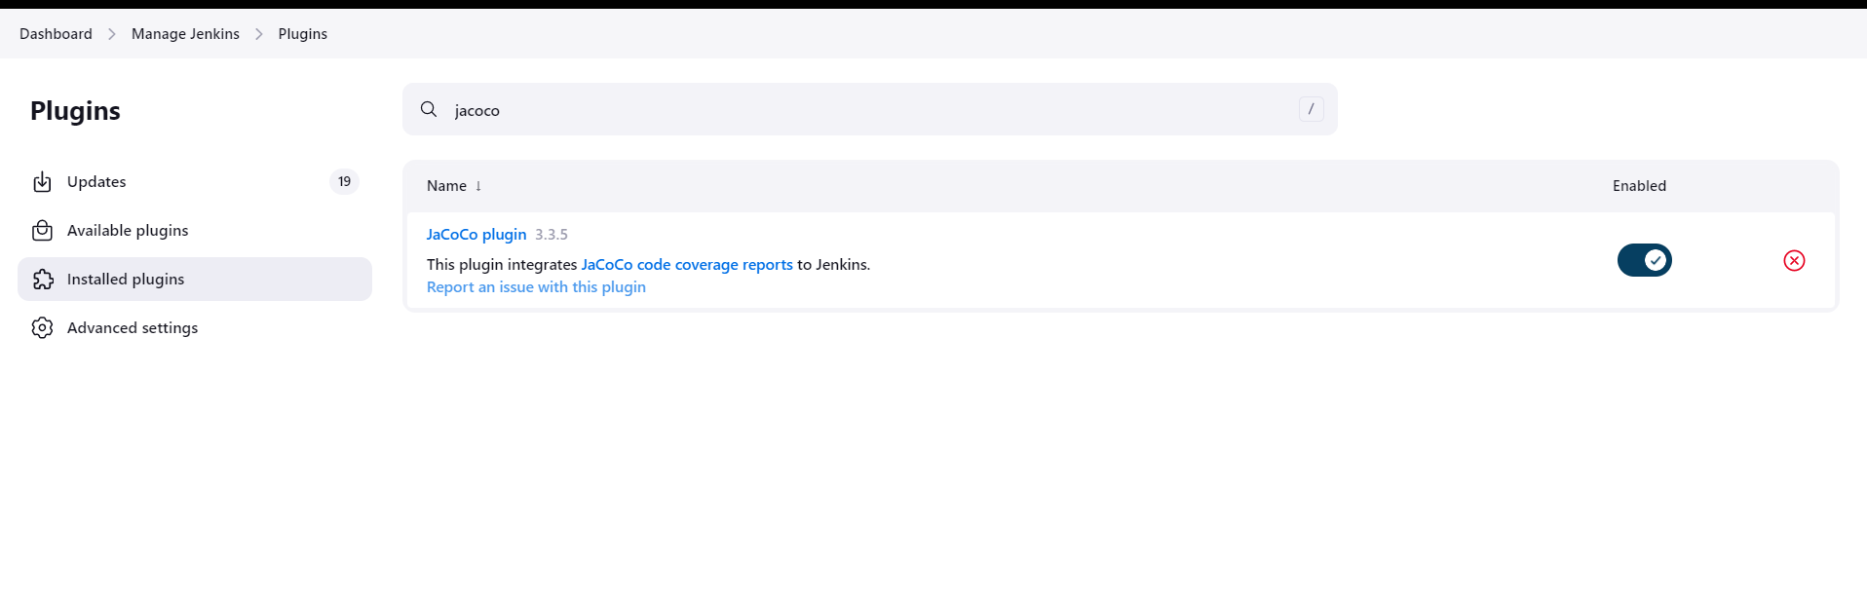

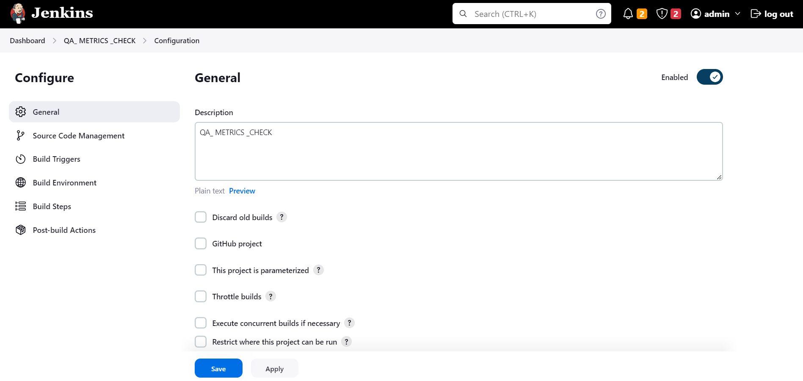

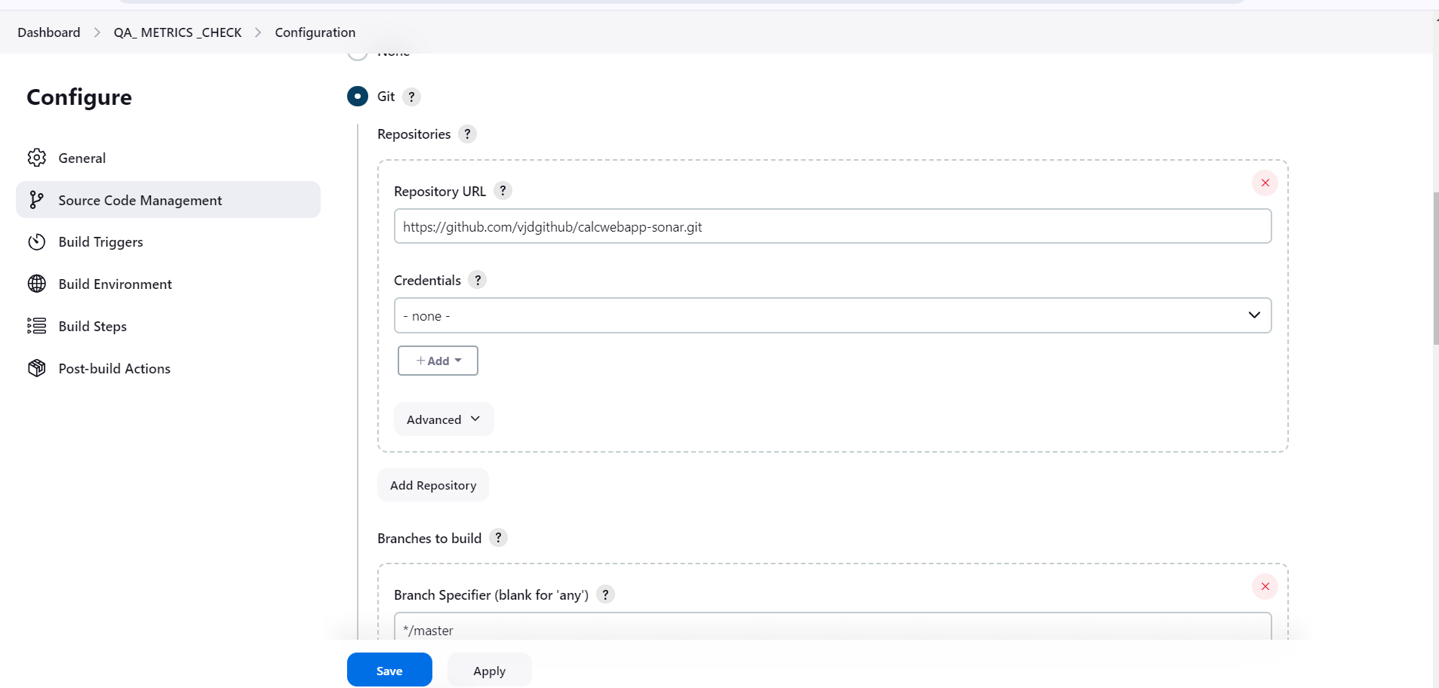

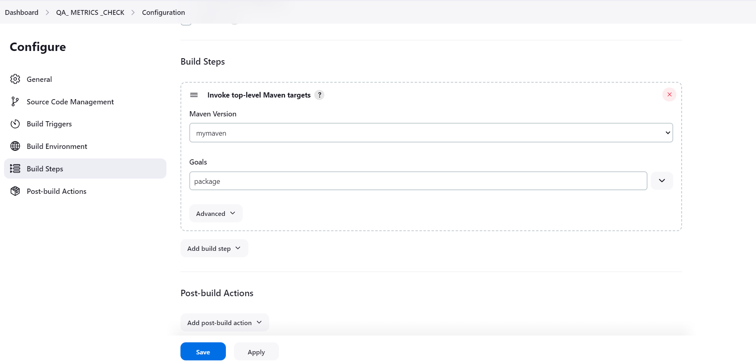

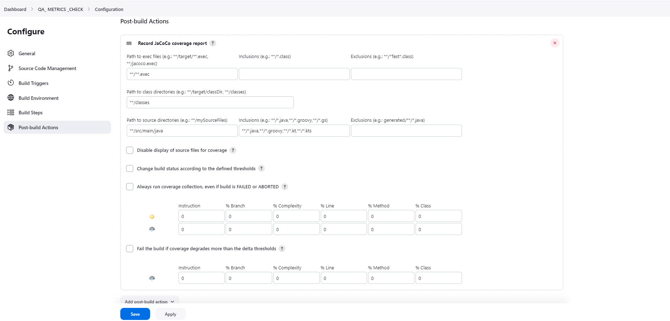

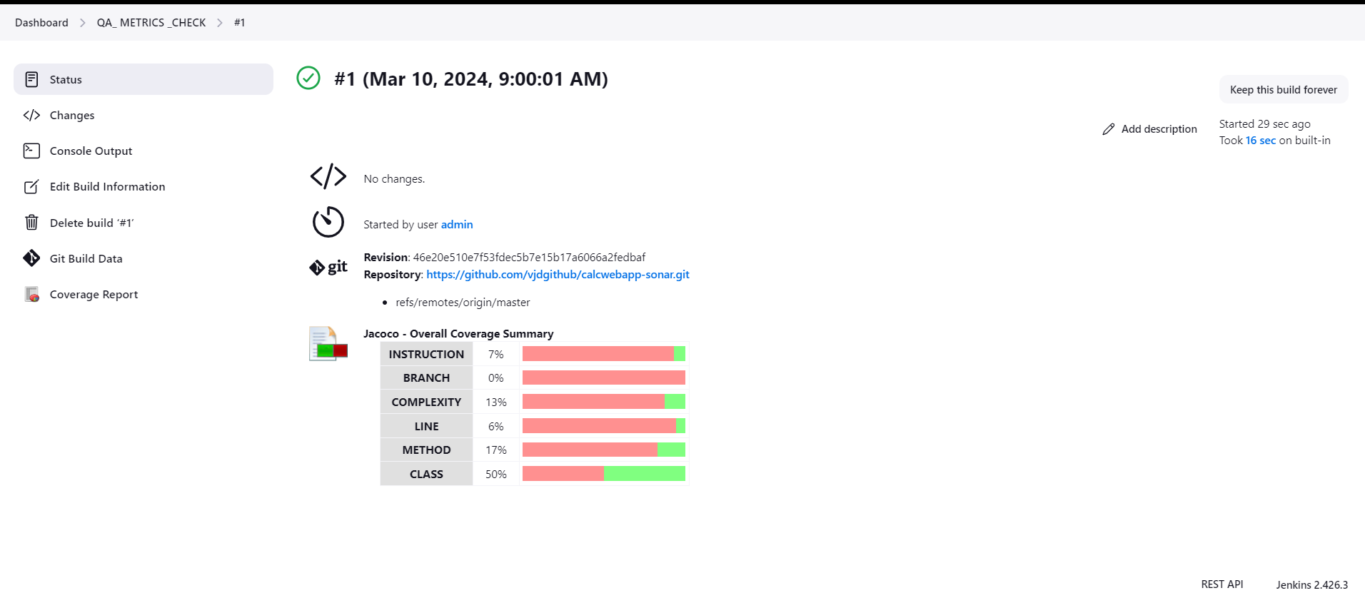

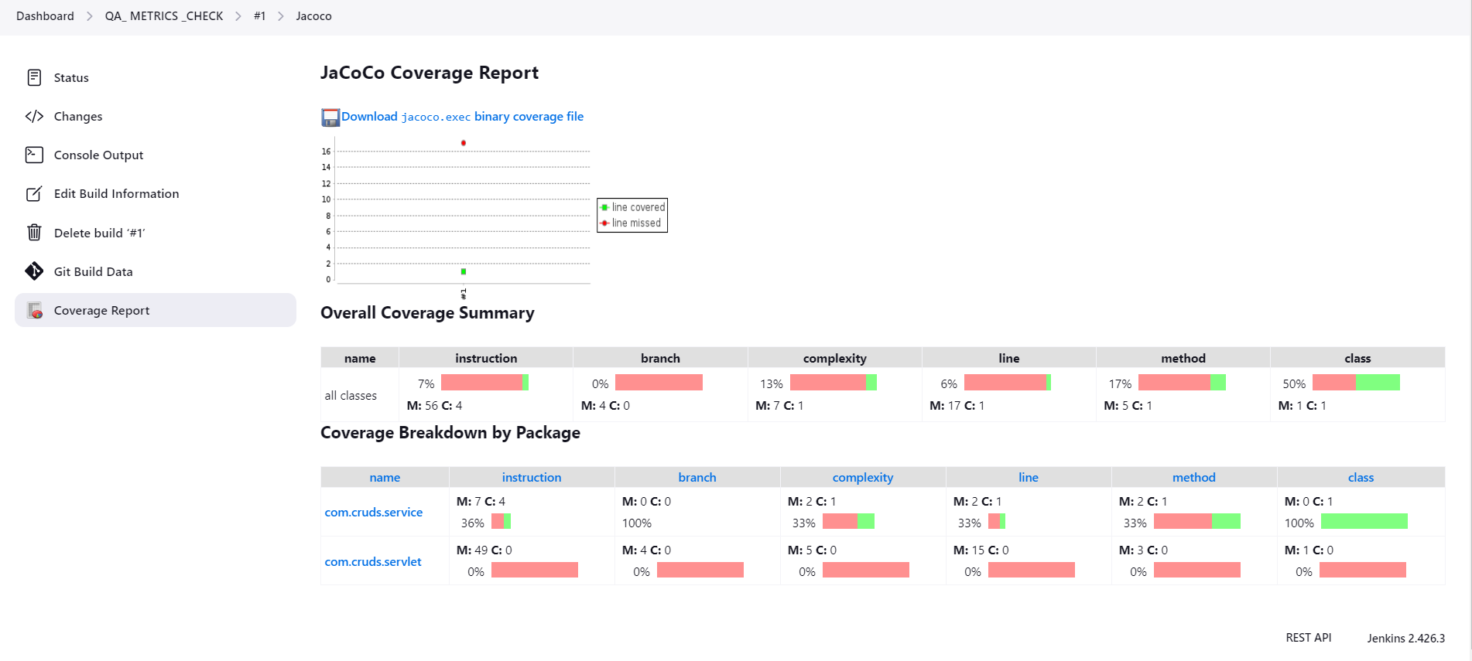

• Create a freestyle project with the name QA_ PACKAGE in Jenkins to create an executable jar/war file.

Take a screenshot of the target folder created in the workspace.

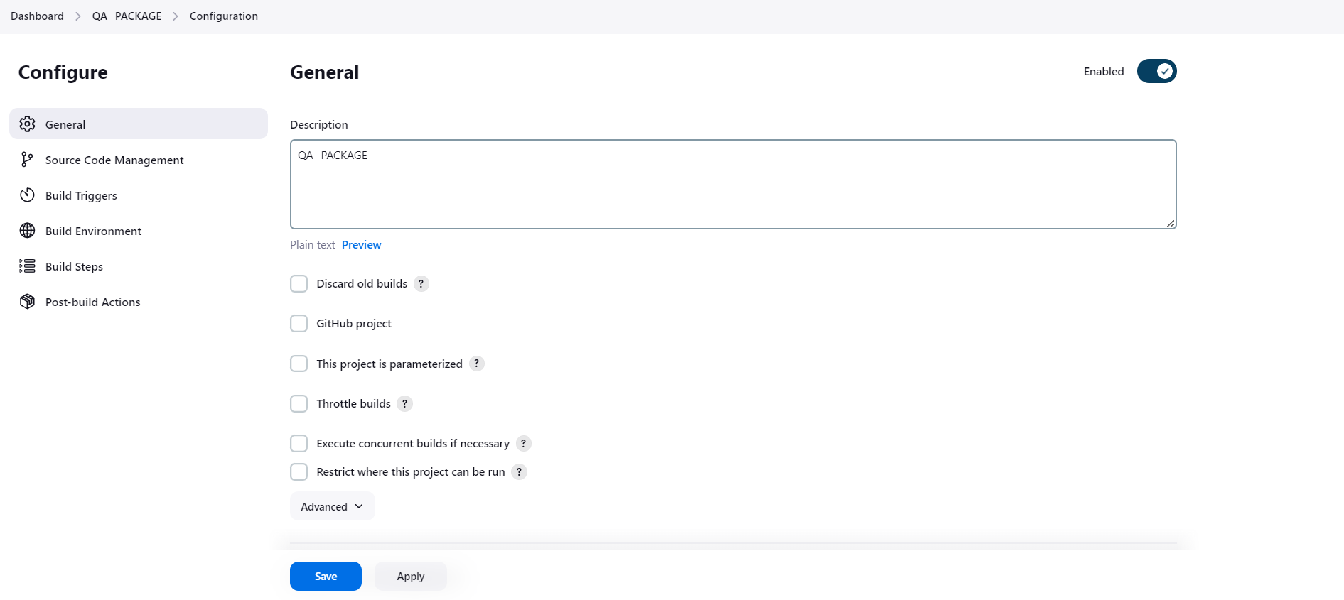

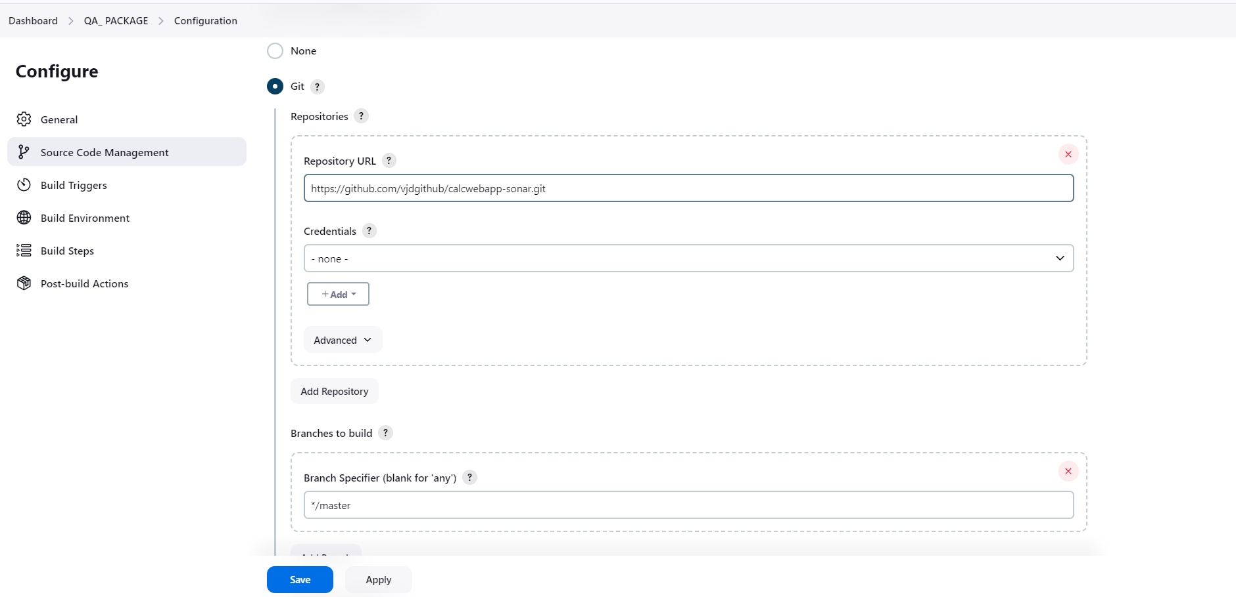

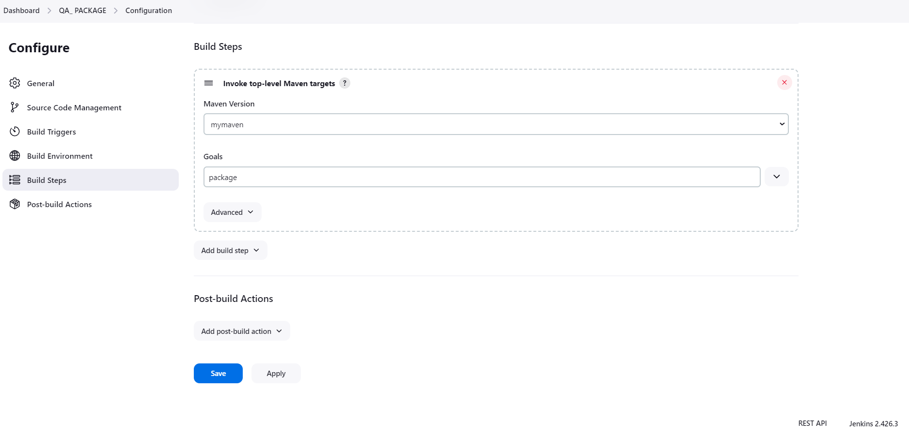

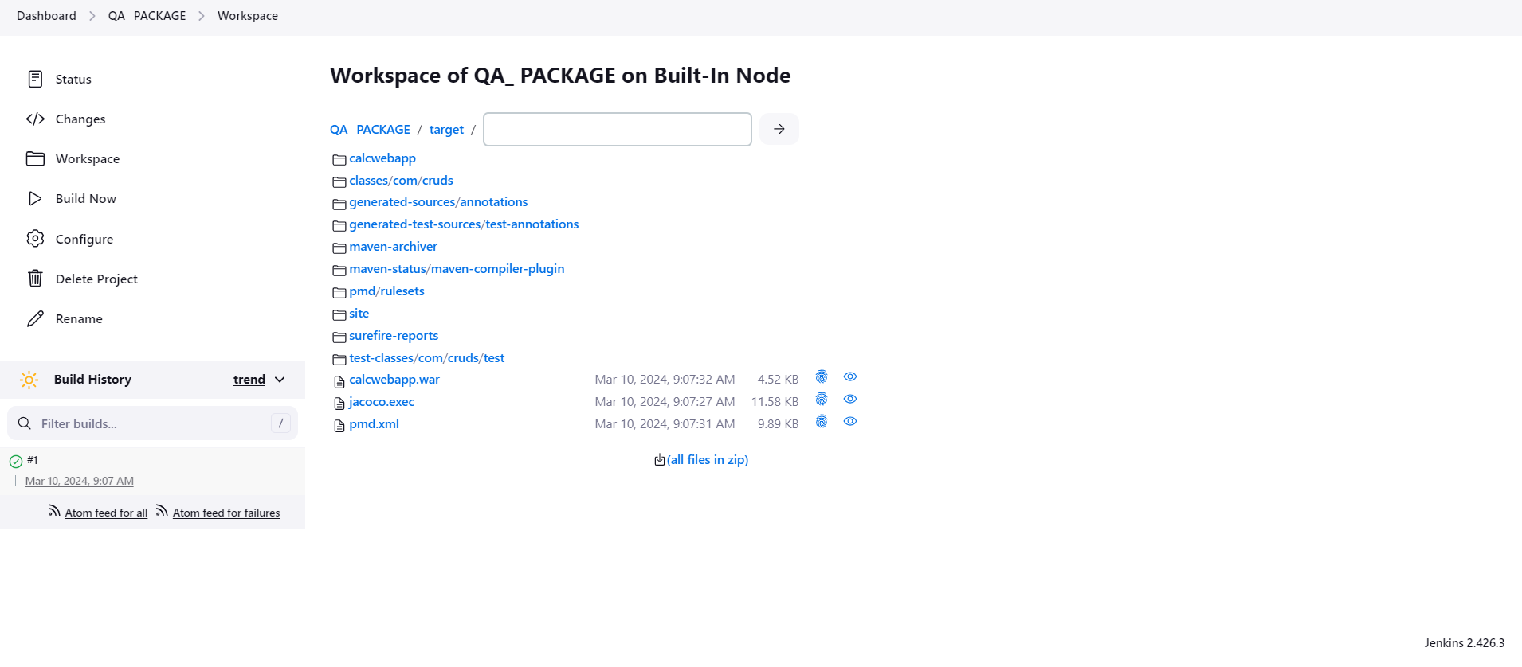

• Create a pipeline named SAMPLE_COMPILE_VIEW with Build Pipeline View option, select DEVELOPER_COMPILE project under layout section, and run the pipeline to check the console output

Take a screenshot of the pipeline dashboard showing the status of the projects

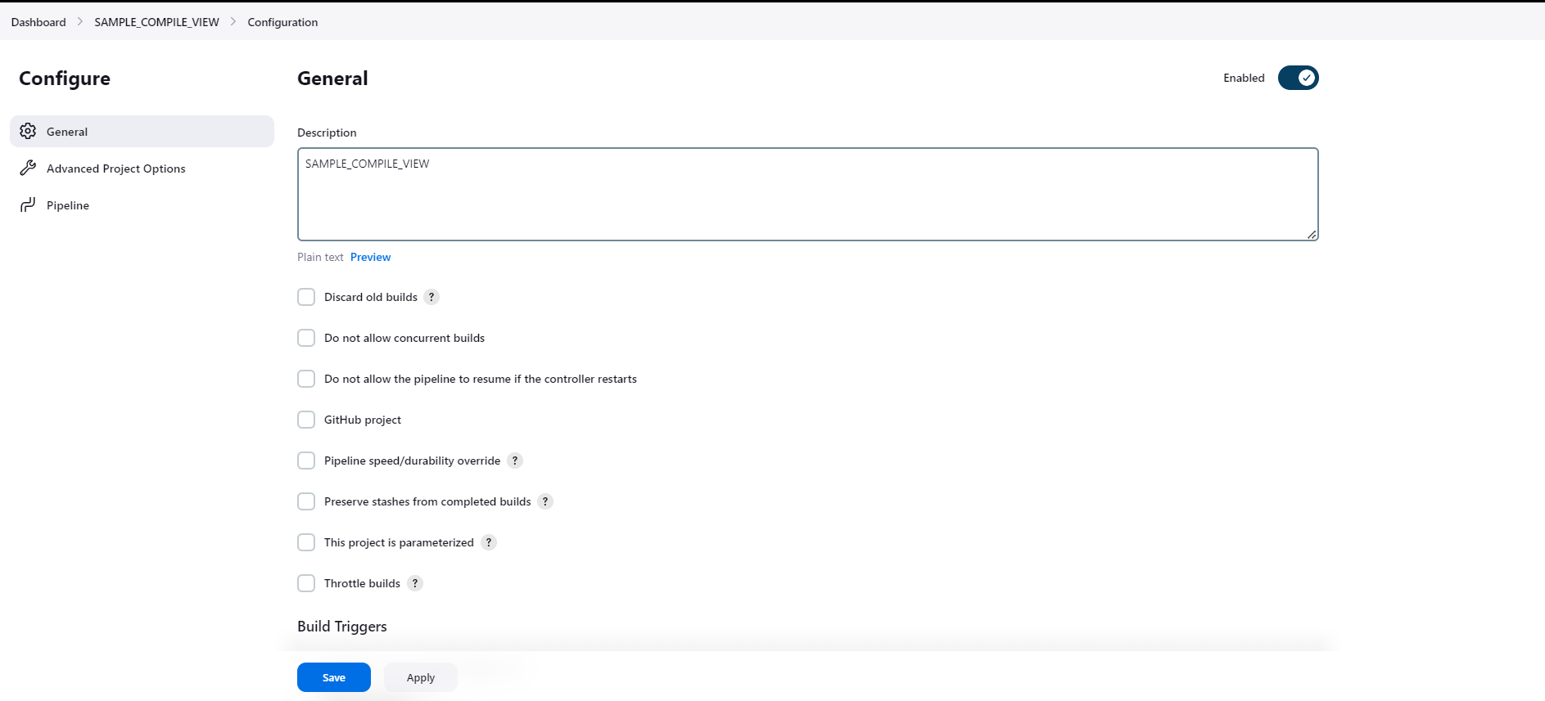

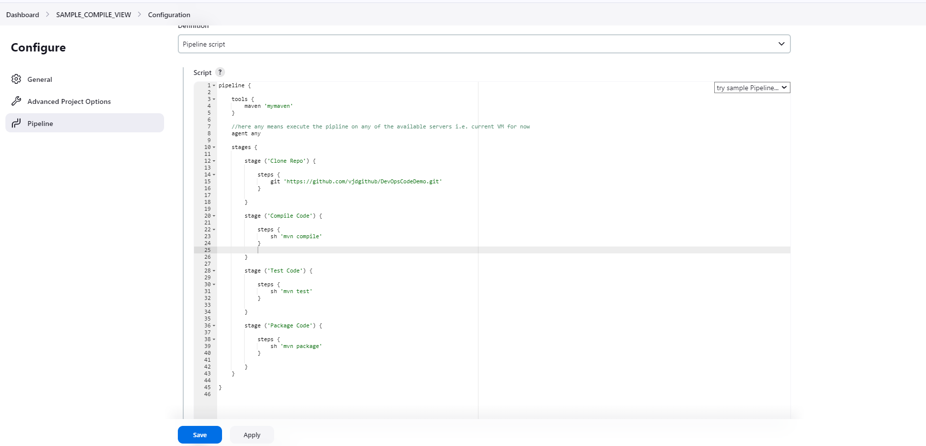

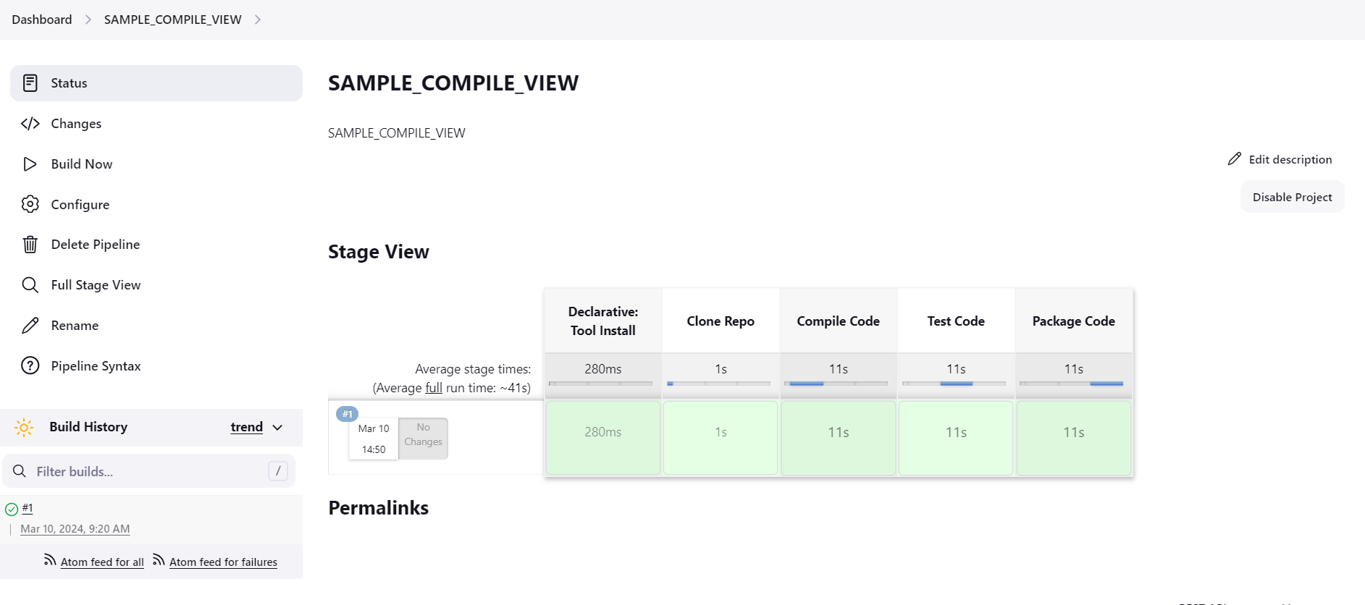

• The pipelines can also be extended to running web tests and load tests. Explain how you would do the same using Jenkins?

By adding **paralell** command we can achieve the extension of pipeline to running web tests and load tests. Below is the sample code

node **{**

stage**(**'Build'**)** **{**

*// Run the Taurus build*

**}**

stage**(**'Performance Tests'**)** **{**

parallel**(**

**BlazeMeterTest:** **{**

dir **(**'Taurus-Repo'**)** **{**

sh 'bzt <file_name>.yml -report'

**}**

**},**

**Analysis:** **{**

sleep 60

**})**

**}**

stage**(**‘Deploy’**)** **{**

**}**

The above information taken from Jenkins blog as below:

<https://www.jenkins.io/blog/2017/08/17/speaker-blog-blazemeter/>